**SUMMER TRAINING PROJECT REPORT**

**ON**

**“ONLINE SHOPPING WEBSITE”**

**Submitted in partial fulfillment for the requirement for the**

**award of the degree of**

**BACHELOR OF ENGINEERING**

**(COMPUTER SCIENCE AND ENGINEERING)**



JUNE-JULY, 2021

**SUBMITTED TO:**

Er. Rajani Misra (E8033)

**SUBMITTED BY:**

NAME(S): Chirag Yadav

Mansi Singh Rajput

Tavishi Vemuri

UNIVERSITY UID: 20BCS5767

20BCS5936

20BCS5946

**DEPARTMENT OF COMPUTER SCIENCE & ENGINEERING**

**CHANDIGARH UNIVERSITY GHARUAN, MOHALI**

### CERTIFICATE

This is to certify that the work embodied in this Project Report entitled **“ ONLINE SHOPPING WEBSITE ”** being submitted by **“ Chirag Yadav, Mansi Singh Rajput, Tavishi Vemuri ” -** UID **“ 20BCS5767, 20BCS5936, 20BCS5946 ” ,** 2nd Semester for partial fulfillment of the requirement for the degree of **“ Bachelor of Engineering in Computer Science & Engineering ”** discipline in “ **Chandigarh University** ” during the academic session Jan-Jun 2021 is a record of bonafide piece of work, carried out by student under my supervision and guidance in the **“ Department of Computer Science & Engineering ”, Chandigarh University.**

**APPROVED & GUIDED BY:** Er. Rajani Misra (E8033)

**CHANDIGARH UNIVERSITY, GHARUAN, MOHALI**

**CANDIDATE'S DECLARATION**

We hereby declare that we have undertaken Summer Training and developed project titled ________ONLINE SHOPPING WEBSITE_________ during a period from ___JUNE___ to ___JULY____ in partial fulfillment of requirements for the award of degree of B.E (COMPUTER SCIENCE & ENGINEERING) at CHANDIGARH UNIVERSITY GHARUAN, MOHALI. The work which is being presented in the training report submitted to Department of Computer Science & Engineering at CHANDIGARH UNIVERSITY GHARUAN, MOHALI is an authentic record of training work.

**Signature of the Student**

Chirag Yadav - 20BCS5767

Mansi Singh Rajput - 20BCS5936

Tavishi Vemuri - 20BCS5946

**APPROVED & GUIDED BY:** Er. Rajani Misra (E8033)

**ABSTRACT**

The Online Shopping is a web-based application intended for online retailers. The main objective of this application is to make it interactive and its ease of use. It would make searching, viewing and selection of a product easier. It contains a sophisticated search engine for user's to search for products specific to their needs. The search engine provides an easy and convenient way to search for products where a user can Search for a product interactively and the search engine would refine the products available based on the user’s input. The user can then view the complete specification of each product. They can also view the product reviews and also write their own reviews. The application also provides a drag and drop feature so that a user can add a product to the shopping cart by dragging the item in to the shopping cart. The main emphasis lies in providing a user-friendly search engine for effectively showing the desired results and its drag and drop behavior.

This project is an attempt to provide the advantages of online shopping to customers. It helps buying the products anywhere through internet by using an android device. Thus, the customer will get the service of online shopping and home delivery of his favorite products.

Since the application is available in the Smartphone it is easily accessible and always available.

**Acknowledgement**

I take this occasion to thank God, almighty for blessing us with his grace and taking our endeavor to a successful culmination. I extend my sincere and heartfelt thanks to our esteemed guide, mentor, project incharge, Mrs. Rajani Misra, for providing us with the right guidance and advice at the crucial junctures and for showing us the right way. I extend my sincere thanks to our respected Head of the division, for allowing us to use the facilities available. I would like to thank the other faculty members also, at this occasion. Last but not the least, I would like to thank my friends and family for the support and encouragement they have given us during the course of our work.

**CONTENTS**

**Topic Page No.**

***Certificate by Course Website/Company/Industry/Institute 1***

***Candidate’s Declaration 2***

***Abstract 3***

***Acknowledgement 4***

**CHAPTER 1** **INTRODUCTION 7-8**

**1.1** Introduction 7

**1.2** Need of the application 7

**1.3** Objectives 8

**1.4** Platform Specifications – Deployment 8-9

**1.4.1** Hardware Specifications 8

**1.4.2** Software Specifications 9

**CHAPTER 2 TRAINING WORK UNDERTAKEN 10-14**

**2.1** Technology Used 11-12

**2.1.1** Features of MySQL 12

**2.2** Why to use these 12

**2.3** Methodology 13-14

**2.3.1** What is Online Shopping 13

**2.3.2** Features of Online Shopping 13

**2.3.3** User of Online Shopping 13

**2.3.4** Functionality performed by costumer user 14

**2.3.5** Functionality performed by admin user 14

**2.4** Design  14-15

**2.4.1** Design Goal 14

**2.4.2** Procedural/Modular Approach 14

**CHAPTER 3 RESULTS AND DISCUSSION 16-27**

**3.1** Analysis 16

**3.1.1** The Convenience Aspect 16

**3.1.2** The Merchandise Aspect 16

**3.1.3** The Cost Aspect 16

**3.2** System Feasibility 17

**3.3** Screenshot with Project Details 18

**3.3.1** Main Interface 18

**3.3.2** User Login and Register Interface 20

**3.3.3** Admin Panel Interface 21

**3.3.2** Products 22

**3.3.4** Shopping Cart 25

**3.4** Result & Challenges 25

**CHAPTER 4 CONCLUSION AND FUTURE SCOPE 26-27**

**4.1** Conclusion 26

**4.2** Future Scope 26

**4.3** Limitations 27

**REFERENCES** 28

**CHAPTER - 1**

**INTRODUCTION**

**1.1 Introduction:**

The project Fashion Shop has been developed on HTML, PHP, CSS, Java Script and My SQL. An online shopping store which will allow formal and informal merchants in developing countries to advertise and sell their good on the internet. This would permit rural communities to make their wares available to the rest of the world via the World Wide Web. The objective of this project is to create an e-commerce web portal with a content management system which would allow product information to be updated securely using a mobile device. The web portal will have an online interface in the form of an e-commerce website that will allow users to buy goods from the merchants. There are two types of users available in the project. First one is Customer and second one is Admin. Customers user have limited access right to access the system while the admin users have full control over the system. I have used PHP for business logic. MySQL as a database.HTML for structure designing.CSS for web page formatting. Java Script for validation and animation. I have also attached the project video and screens this project look into it.

**1.2 Need of the application:**

There are a large number of commercial Online Shopping websites offering large number of products tailored to meet the shopping interests of large number of customers. These online marketplaces have thousands of products listed under various categories.

Problem:

* The basic problems with the existing systems are the non-interactive environment they provide to the users.
* The use of traditional user interfaces which make continuous post backs to the server; each post back makes a call to the server, gets the response and then refreshes the entire web form to display the result. This scenario adds an extra trade off causing a delay in displaying the results
* Use of traditional and non-user-friendly interfaces that are hard to use

Solution:

* The motive of this Online Shopping Web Application is to allow the user to play with the search tool and create different combinatorial search criterion to perform exhaustive search.
* Provide Interactive interface through which a user can interact with different areas of application easily.
* The user can filter the list based on various parameters.
* Provide feature thereby allowing the user to add products to or remove products from the shopping cart by dragging the products in to or out of the shopping cart.

**1.3 Objectives:**

The project objectives are:

* To make the shopping easier and comfortable
* To serve the customers without wasting their precious time
* To reach the products to the customer's address with great care
* To represent as a compete in the e-commerce all over the world
* To make it more convenient for users as
* users can further filter the list based on various parameters.
* users can add a product to or remove a product from the shopping cart
* A user can view the complete specification of the product along with various images.

**1.4 Platform Specifications – Deployment**

**1.4.1 Hardware Specification**

* Processor: Pentium 1.0 GHz or higher
* RAM: 1024 MB or more
* Minimum Space Required 100 MB
* Display 16-bit color
* Storage: 10GB or more

**1.4.2 Software Specification**

* Operating Environment Win 2000/XP
* Platform .Net Framework & IIS Visual Studio 2008
* Database SQL Server 2005
* XAMPP server
* Any Browser

**CHAPTER - 2**

**TRAINING WORK UNDERTAKEN**

**2.1 Technology Used**

**Overview of the technology:**

**Front End:** HTML, CSS, JavaScript

* **HTML:** HTML is used to create and save web document. Notepad/Notepad++.
* **CSS:** (Cascading Style Sheets) Create attractive Layout.
* **JavaScript:** It is a programming language, commonly use with web browsers.

**Back End:** PHP, MySQL.

* **PHP:** Hypertext Preprocessor (PHP) is actinology that allows software developers to create dynamically generated web pages, in HTML, XML, or other document types, as per client request. PHP is open source software.
* **MySQL Server:**

MySQL is developed, distributed and supported by Oracle Corporation. MySQL is a database system used on the web it runs on a server. MySQL is ideal for both small and large applications. It is very fast, reliable, and easy to use. It supports standard SQL MySQL can be compiled on a number of platforms.

The data in MySQL is stored in tables. A table is a collection of related data, and it consists of columns and rows. Databases are useful when storing information categorically.

MySQL is a database, widely used for accessing querying, updating, and managing data in databases

**2.1.1 Features of MySQL:**

Internals and portability:

* Written in C and C++.
* Tested with a broad range of different compilers.
* Works on many different platforms.
* Tested with Purify (a commercial memory leakage detector) as well as with Val grind, a GPL tool.
* Uses multi-layered server design with independent modules.
* Security:
* A privilege and password system that is very flexible and secure, and that enables host-based verification.
* Password security by encryption of all password traffic when you connect to a server.

**2.2 Why To Use These:**

* Leading open source DBMS
* Ease of use -No frills
* Fast
* Robust
* Security
* Multiple OS support
* Free
* Technical support
* Support large database-up to 50 million rows, file size limit up to 8 Million TB

**2.3 Methodology**

**2.3.1 What is Online Shopping?**

Online shopping is a form of electronic shopping store where the buyer is directly online to the seller's computer usually via the internet. There is no intermediary service. The sales and purchases transaction is completed electronically and interactively in real-time. The development of this new system contains the following activities which try to develop on-line application by keeping the entire process in the view of database integration approach. User gets its email id and password to access their account. Administrator of Shopping Cart System has multiple features such as Add, Delete, Update shopping Items.

**2.3.2 Features of Online Shopping:**

* Secure registration and profile management facilities for Customers.
* Browsing through the e-Mall to see the items that are there in each category of products new arrival, shirts, shoes, watches etc.
* Creating a Shopping cart so that customer can Shop N number of items and checkout finally with the entire shopping cart.
* Customers should be able to mail the Shop about the items they would like to see in the Shop.
* Secured mechanism for checking out from the Shop. Updates to customers about the Recent Items in the Shop.
* Uploading Most Purchased Items in each category of products in the Shop like Featured Categories, New Arrival etc.

**2.3.3 User of Online Shopping:**

There are two types of users available in the project:

* Customer: With limited access
* Admin: With full access

**2.3.4 Functionality performed by customer users:**

* Registration for customer
* Login for customer
* Forgot password for customer
* Change password for customer Edit profile for customer
* View his/her payment history
* View his/her shopping history
* Customer can also track the order of the products

**2.3.5 Functionality performed by Admin users:**

* Login for admin
* Forgot password for admin
* Edit profile for admin

**2.4 Design:**

**2.4.1 Design Goal**

* The design of the web application involves the design of the forms for listing the products, search for products, display the complete specification for the product, and design a shopping cart that is easy to use.
* Design of an interactive application that enables the user to filter the products based on different parameters.
* Design of an application that has features like drag and drop etc.
* Design of application that decreases data transfers between the client and the server.

**2.4.2 Procedural/Modular Approach**

Following are all the modules designed for the Online Shopping System.

* **Shopping Products Module**

This module starts when the user visits the home page or when a user searches for a product by entering a search term. This part of the application includes displaying all the products that are available or the products that match the search term entered by the user. The user can then filter these products based on various parameters like product type, price range etc. The user browse through the products and each product would be displayed with an image and its features like operating system supported, number of user licenses and if it is a full version or an upgrade version. A user can add a product to the cart by clicking a button. The user would be able to see the shopping cart summary.

* **Product Description Module**

This module starts when a user visits the product description page. A user can view various images of the product of different sizes. The use can see an enlarged image in a popup window. The user can view the complete specification of the product like its features, operating system supported, system requirements etc.

* **Shopping Cart Module**

This module starts when the user views the shopping cart. All the products that have been added to the shopping cart by the user are listed along with their price and the quantity. The total price of all the products added to cart is displayed. A user can edit the quantity of each product or remove the product from the shopping cart. A user can remove the product from the cart by clicking a button. The total price changes accordingly when a user edits the quantity of a product or when a product is removed from the cart.

**CHAPTER - 3**

**RESULTS AND DISCUSSION**

**3.1 Analysis**

**3.1.1 The Convenience Aspect:**

**Online Shopping:** We never have to leave our home and the stores never close. There are also no overworked sales clerks. We never have to wait for service and there are no worries about parking. We can shop anything we want from here. Women are more anticipated and research online, when come by product online or in-store.

**In-Store:** It's crowded, it's noisy. We physically have to be there when it's open and we have to wait in long lines to pay for everything. Men are less likely to research online, before buying products, compared to women.

**3.1.2 The Merchandise Aspect:**

**Online Shopping:** We can generally get a more extensive view of every product on offer, whereas stores have limited shelf space. It may also be easier to get specifies on each item we are interested in. We can also read the online reviews of others.

**In-Store**: We can physically see what we are getting pick it up and even have a demonstrated. A lot depends on what we are purchasing Buying an iPod online is easy because we know what we are getting but choosing clothes or shoes that way is problematic because we can't try them on first.

**3.1.3 The Cost Aspect:**

**Online Shopping:** Because they don't have to hire sales staff or pay rent. Some online deals can be found much cheaper than in mall and the range of products is wider too.

**In-Store:** Unless there's a sale, we may wind up paying more if we are buy it at a retail outlet. But if we are into dickering, we can at least argue down the price with a manager-something we can't do on our computer, unless we are buying something on eBay.

According these the demand of online shopping is increasing when compare to in-store shopping, due to rise of mobile and laptop.

**3.2 System Feasibility**

The system feasibility can be divided into the following sections:

**3.2.1 Economic Feasibility**

The project is economically feasible as the only cost involved is having a computer with the minimum requirements mentioned earlier. For the users to access the application, the only cost involved will be in getting access to the Internet.

**3.2.2 Technical Feasibility**

To deploy the application, the only technical aspects needed are mentioned below:

* Operating Environment Win 2000/XP
* Platform .Net Framework & IIS
* Database SQL Server 2005
* Hard Disk

For Users:

* Internet Browser
* Internet Connection

**3.2.3 Behavioral Feasibility**

The application requires no special technical guidance and all the views available in the application are self-explanatory. The users are well guided with warning and failure messages for all the actions taken.

**3.3 Screenshot with Project Details**

**3.3.1 Main Interface**

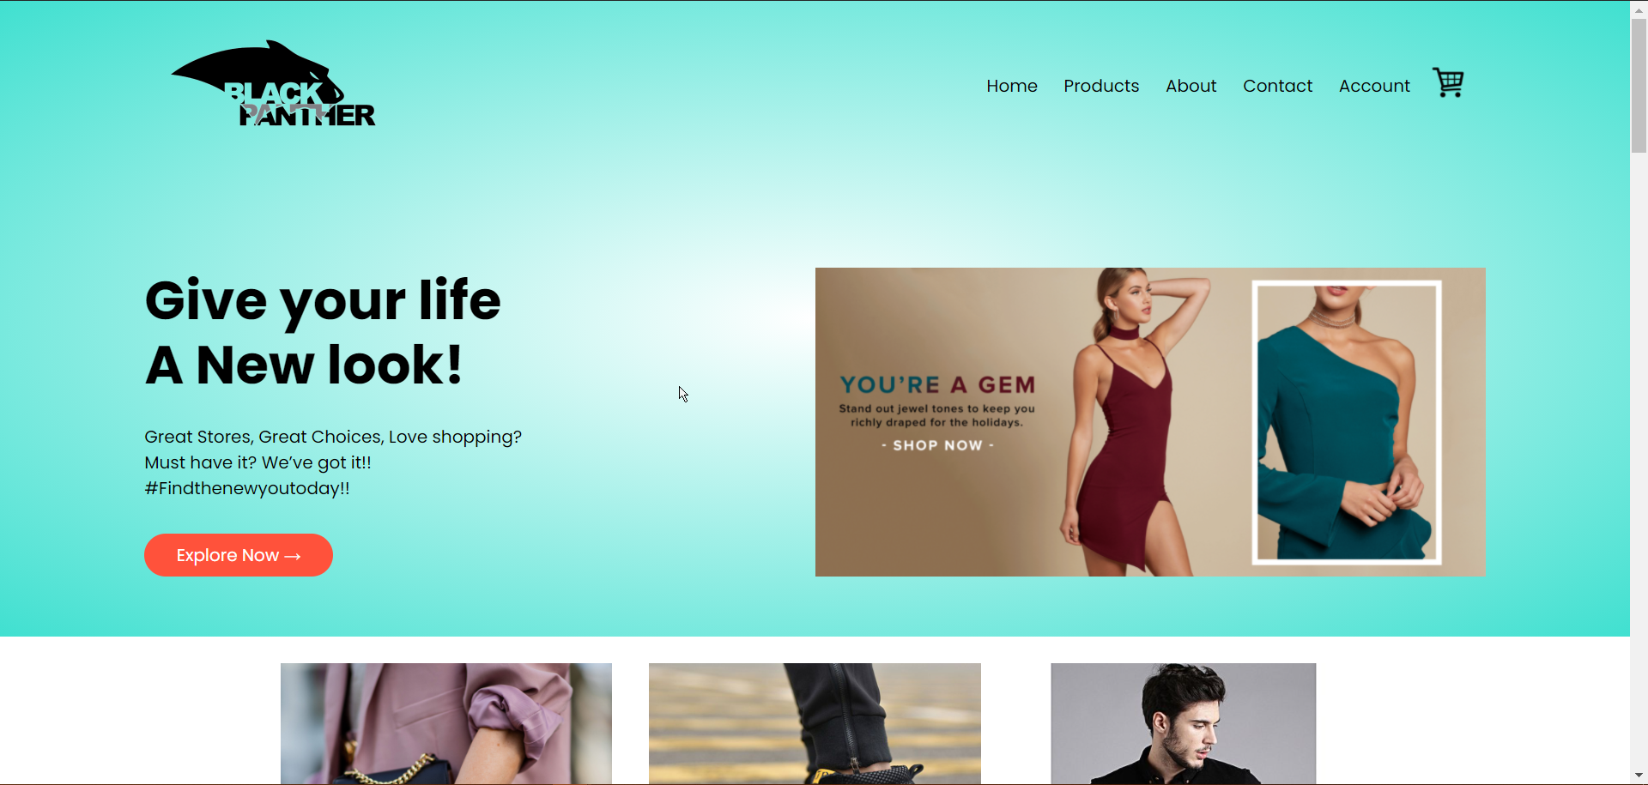

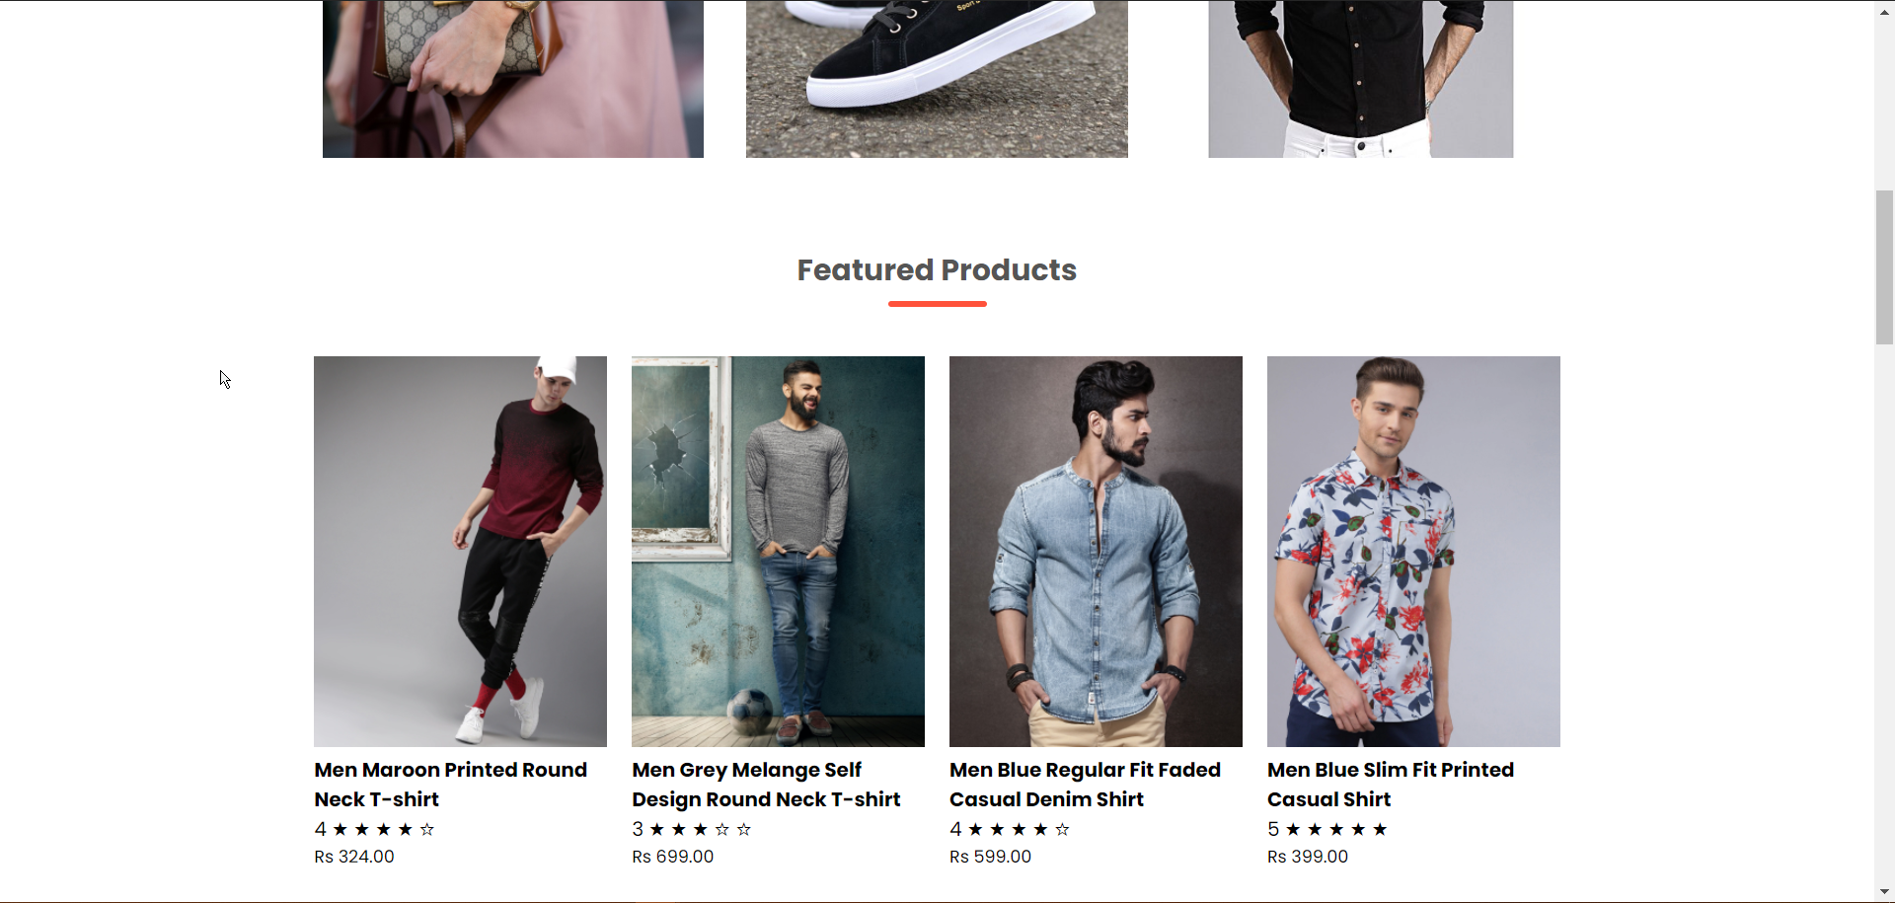

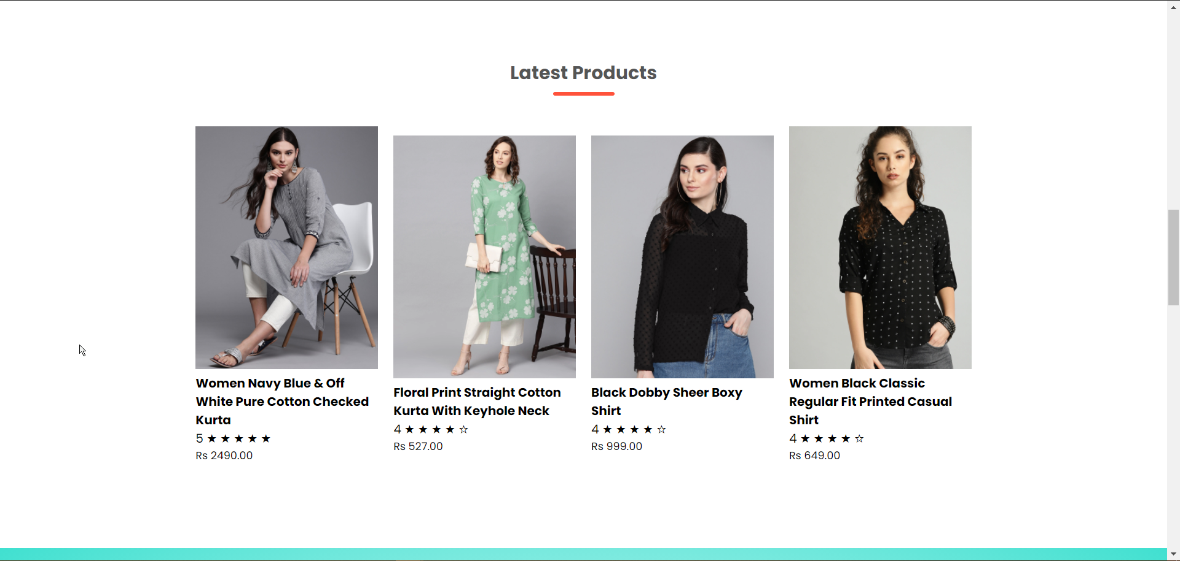

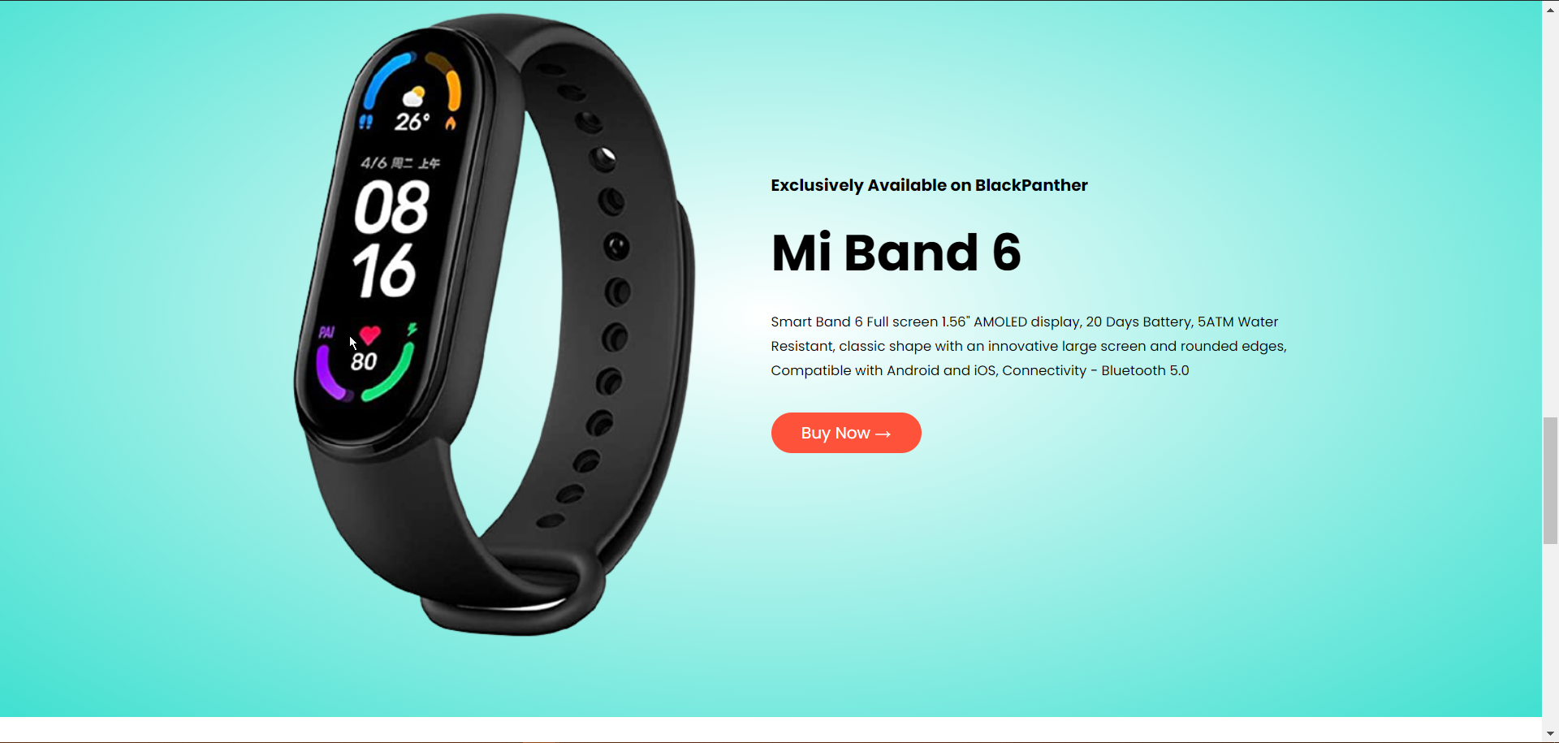

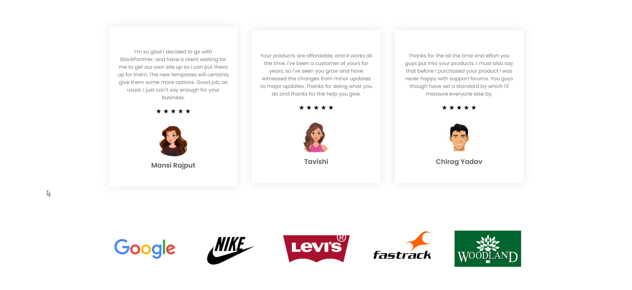



**3.3.2 User Login and Register Interface**

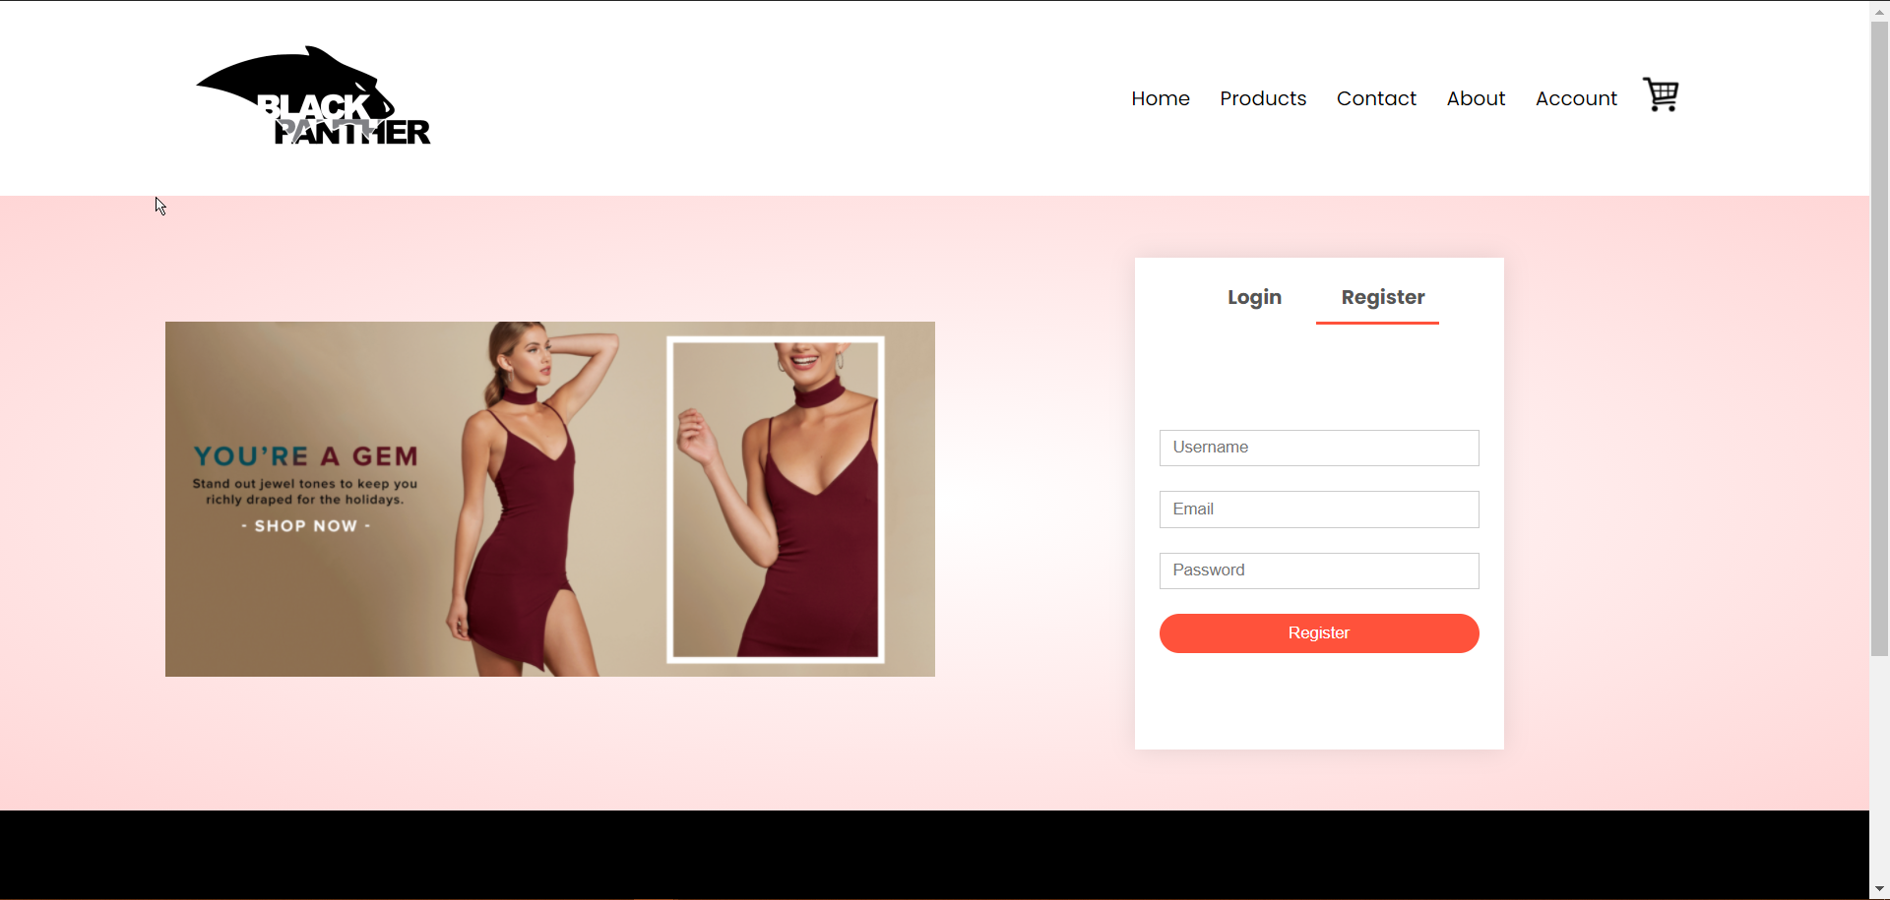

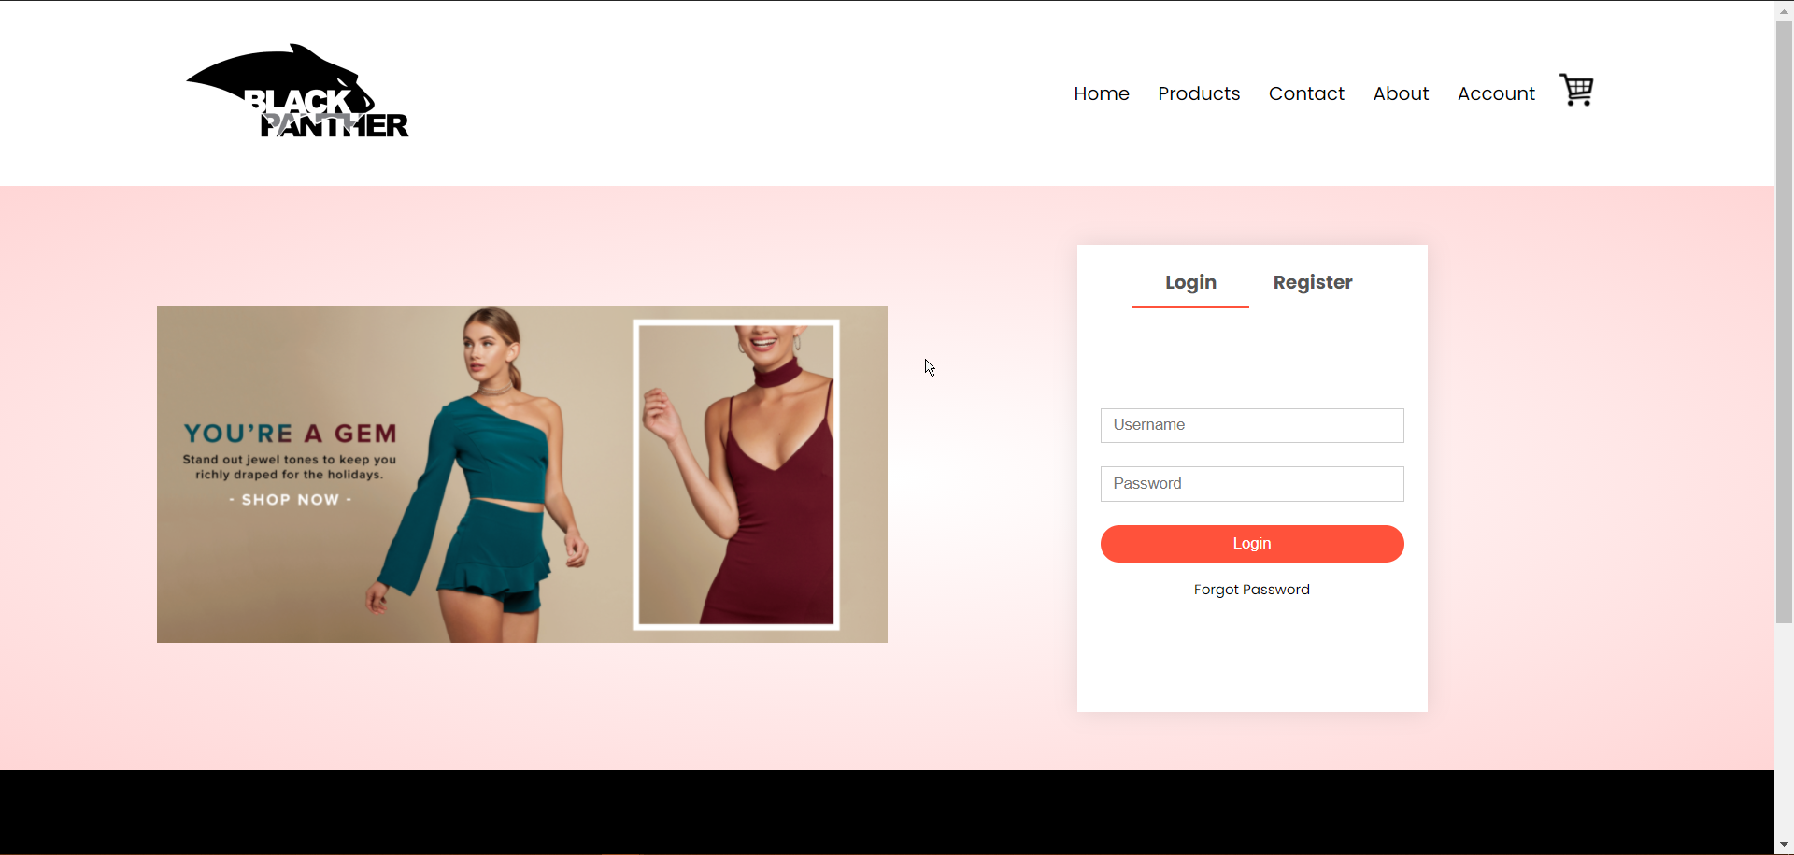

**3.3.3 Admin Panel Interface**

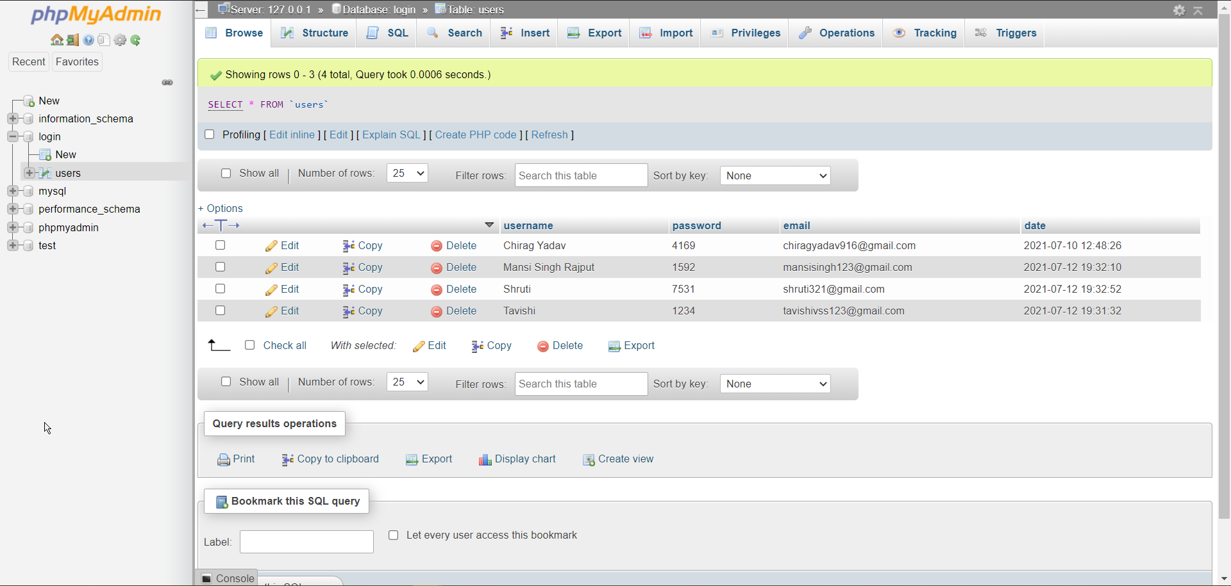

**3.3.2 Products**

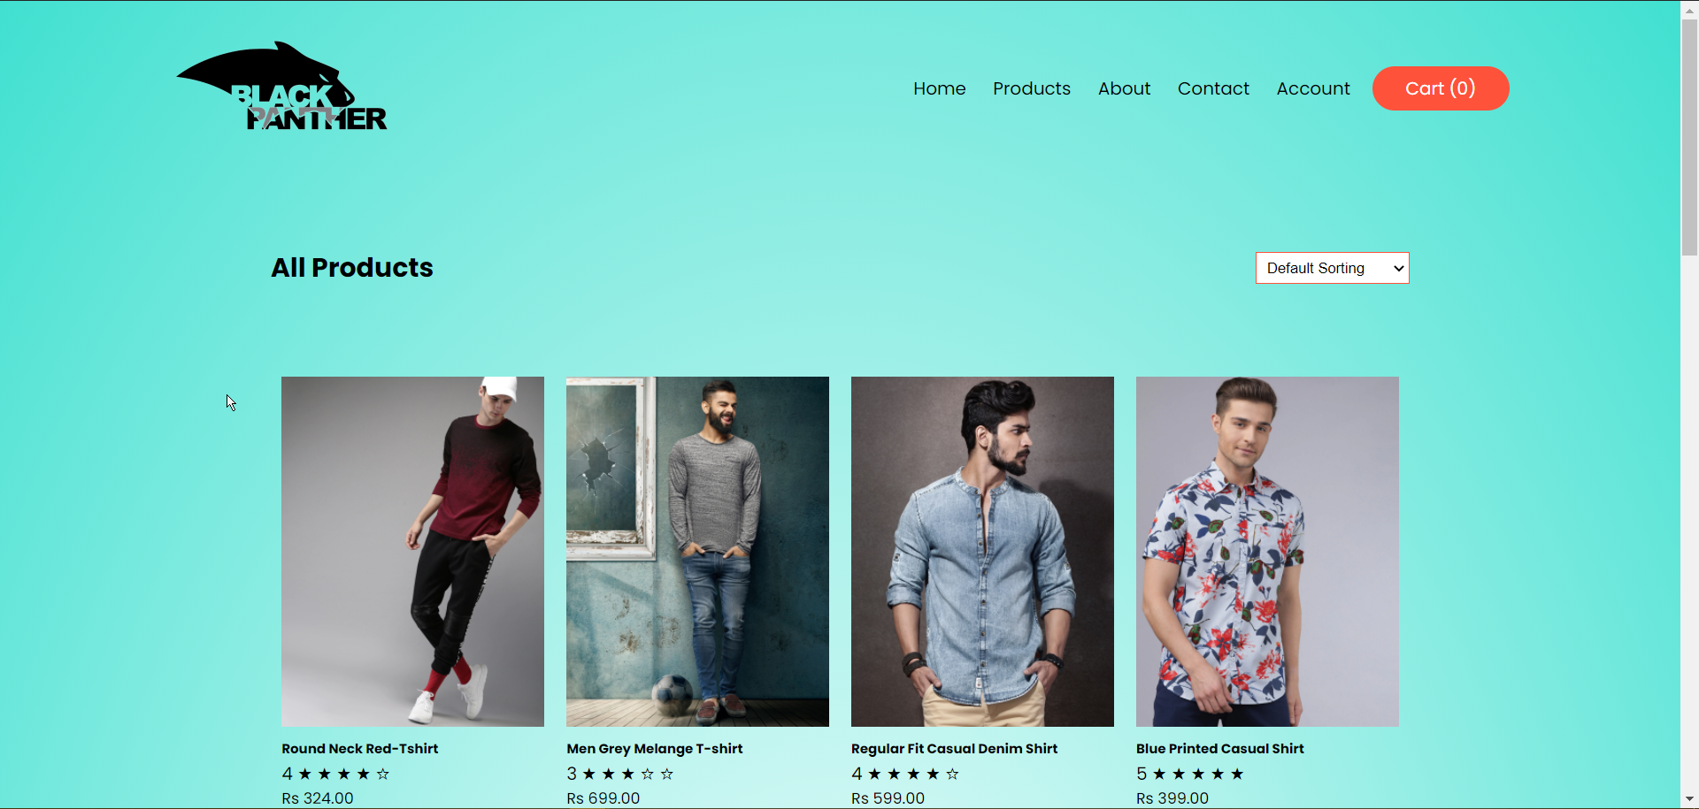

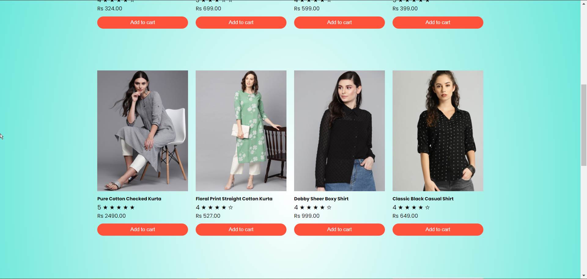

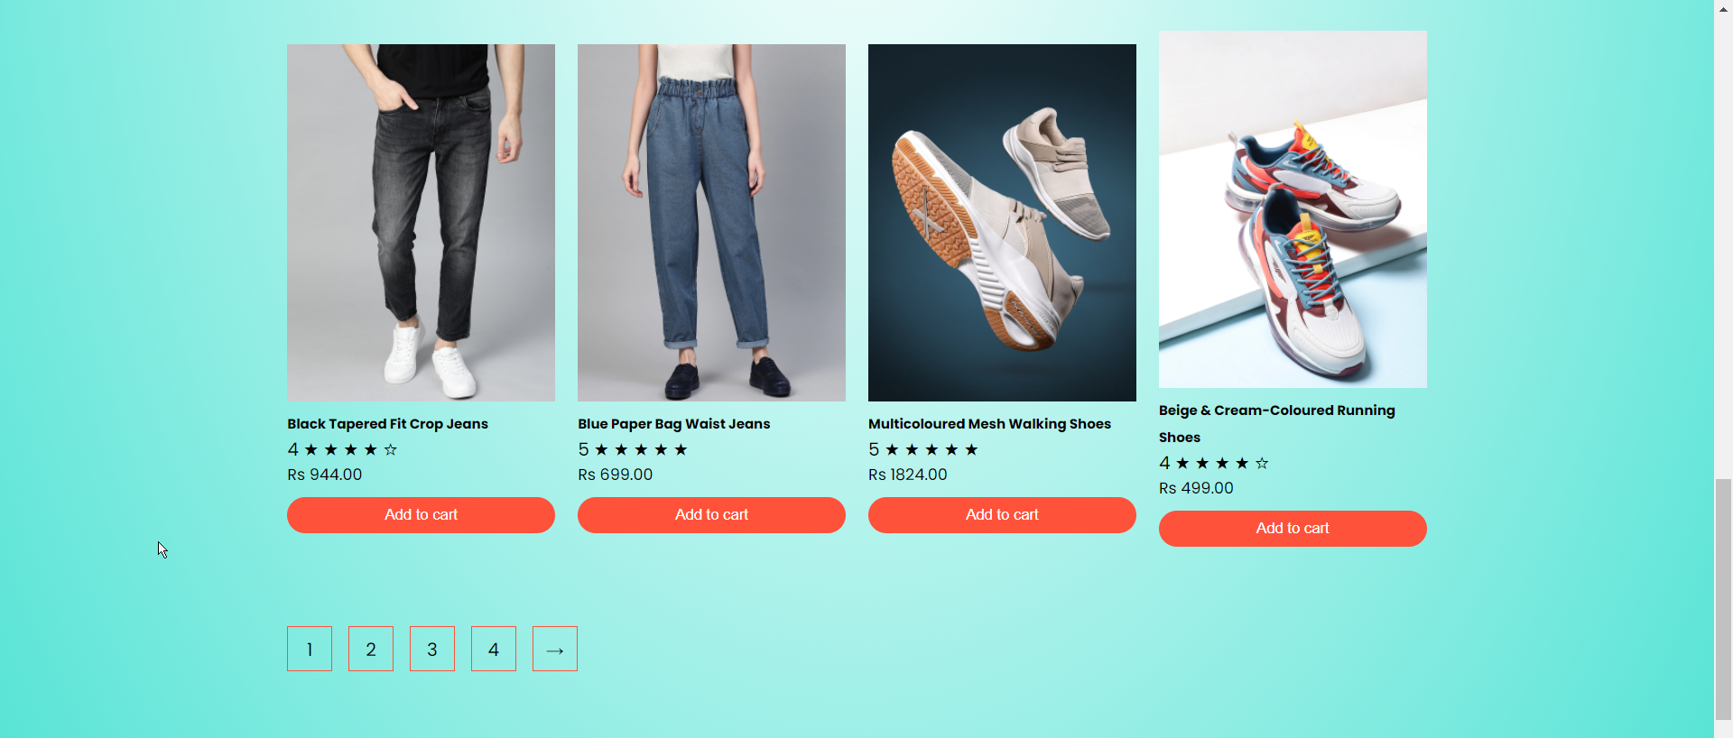



**Product Details**

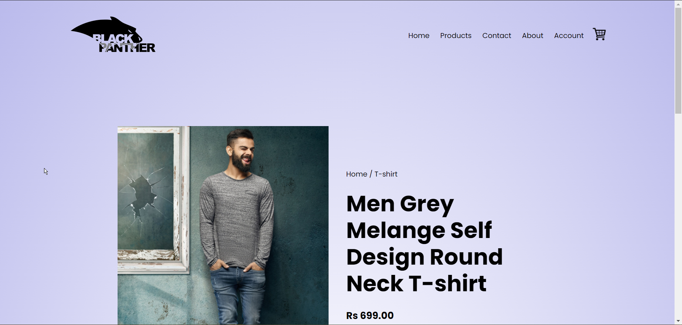

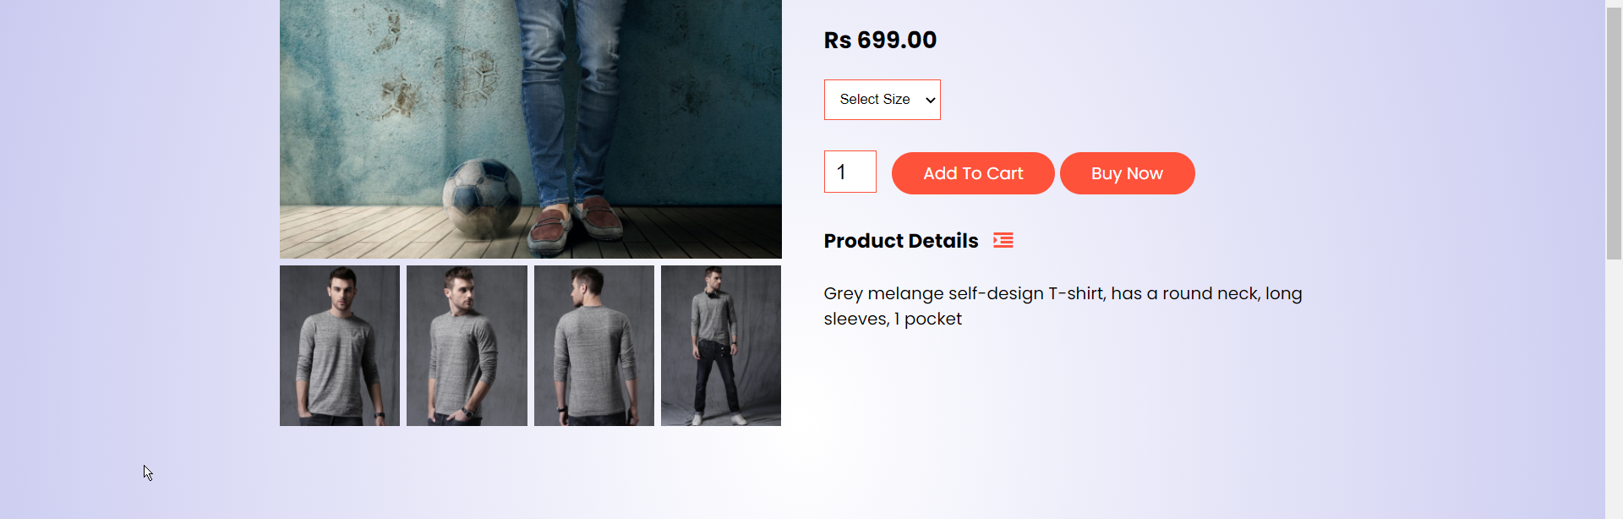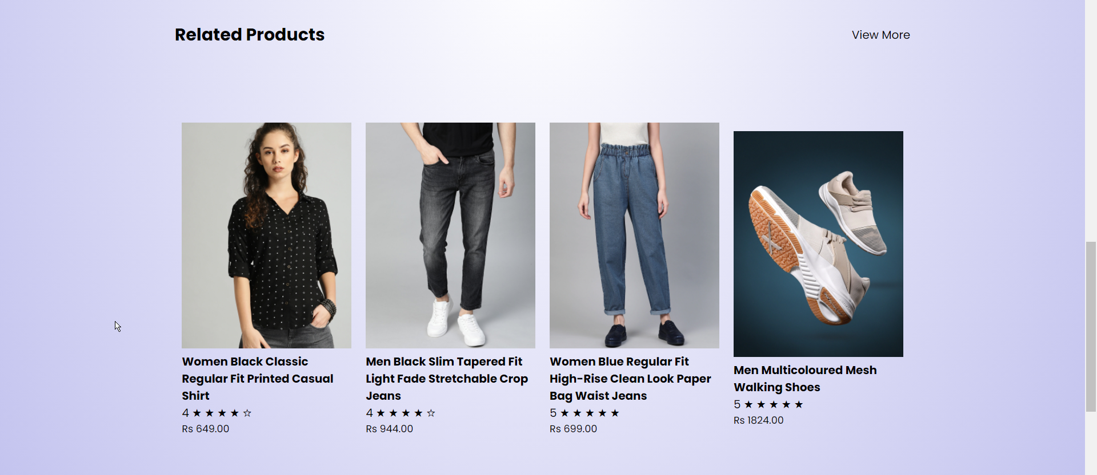

**3.3.4 Shopping Cart**

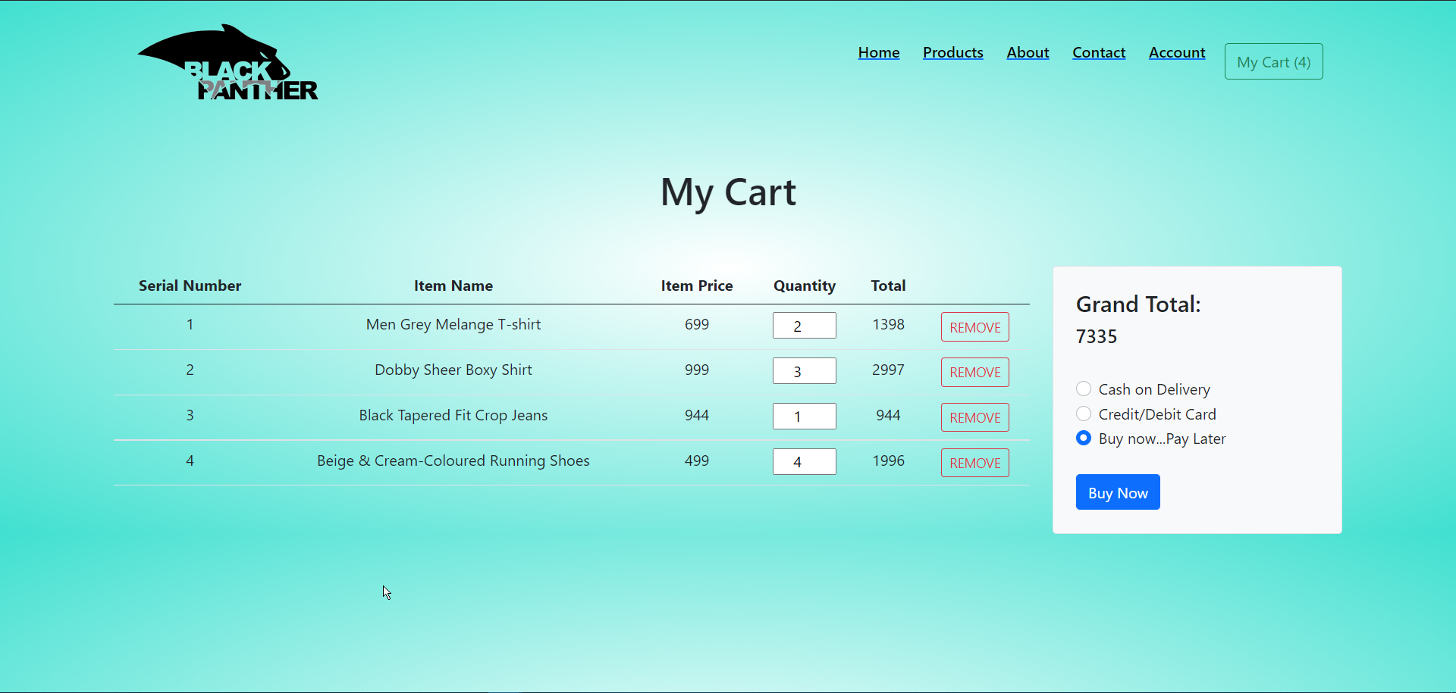

**3.4 Result & Challenges**

The application can be used for any Ecommerce application. It is easy to use, since it uses the GUI provided in the user dialog. User friendly screens are provided. The application is easy to use and interactive making online shopping a recreational activity for users. It has been thoroughly tested and implemented.

**Challenges**

* Compatibility with browsers like Mozilla Firefox, Internet explorer etc
  + Using a layered approach in developing the application which would make the application maintainable.
  + Learning new technologies like using JavaScript for drag and drop behavior, php etc.

The overall idea of doing this project is to get a real time experience. Learn new technologies.

**CHAPTER - 4**

**CONCLUSION AND FUTURE SCOPE**

**4.1 Conclusion**

After having detail study on online shopping, we can see a great change in the behavior of people in many manners like their attitude, buying pattern. In earlier times people use to do manual shopping but now as time changed, people are becoming busy and due to which technology has brought a new revolution Le. online shopping.

As we started doing survey, it came to in notice that young age group people i.e., 15-30 uses of prefer online shopping because it is time and energy saving. But middle age group does not prefer much because they have wrong perception that by seeing the product one can get the goods of proper quality. And even some people don’t prefer using plastic money i.e., credit cards:

The online shopping has a great future but to be successful it is necessary to spread awareness about its benefit.

The project entitled **Online shopping website** was completed successfully. The system has been developed with much care and free of errors and at the same time it is efficient and less time consuming. The purpose of this project was to develop a web application and an android application for purchasing items from a shop.

This project helped us in gaining valuable information and practicalknowledge on several topics like designing web pages using html & css, usage of responsive templates, designing of android applications, and management of database using MySQL. The entire system is secured. Also the project helped us understanding about the development phases of a project and software development life cycle. We learned how to test different features of a project.

This project has given us great satisfaction in having designed anapplication which can be implemented to any nearby shops or branded shops selling various kinds of products by simple modifications.

**4.2 Future Scope**

The following things can be done in future.

* The current system can be extended to allow the users to create accounts and save products in to wish list.
* The users could subscribe for price alerts which would enable them to receive messages when price for products fall below a particular level.
* The current system is confined only to the shopping cart process. It can be extended to have an easy to use check out process.
* Users can have multiple shipping and billing information saved. During checkout they can use the drag and drop feature to select shipping and billing information.
* Want to Increase facilities of this project.
* Want to add printing option.
* Want to develop graphical design.
* Want to publish this website in online.
* Want to remove all the limitations.

**4.3 Limitations**

* This application does not have a built in check out process.
* An external checkout package has to be integrated in to this application.
* Also users cannot save the shopping carts so that they can access later i.e. they cannot create wish lists which they can access later.
* This application does not have features by which user can set price ranges for products and receive alerts once the price reaches the particular range.
* User cannot proceed to the payment gateway because of lack of time.

**References**

**Books**

➤ Beginning PHP6, Apache, MySQL Web Development by Timothy

Boronczyk

➤ Leaming PHP, MySQL & JavaScript: With JQuery, CSS & HTML5 By Robin Nixon

**Online Sources**

* https://www.w3schools.com/html/
* https://www.google.com
* https://www.slideshare.net/dulamkoma/online-shopping-24694373
* https://www.wikipedia.com

**References in Text**

[1] JavaScript Enlightenment, Cody Lindley-First Edition, based on JavaScript 1.5, ECMA-262, Edition

[2] Mc Graw Hill's, Java: The complete reference 7thEdition, Herbert Schildit

[3] Complete CSS Guide Maxine Sherrin and John Allsopp-O'Reilly Media: September 2012

[4] http://www.w3schools.com/html/defualt.asp. http://www.w3schools.com/css/default.asp. http://www.w3schools.com/js/default.asp